

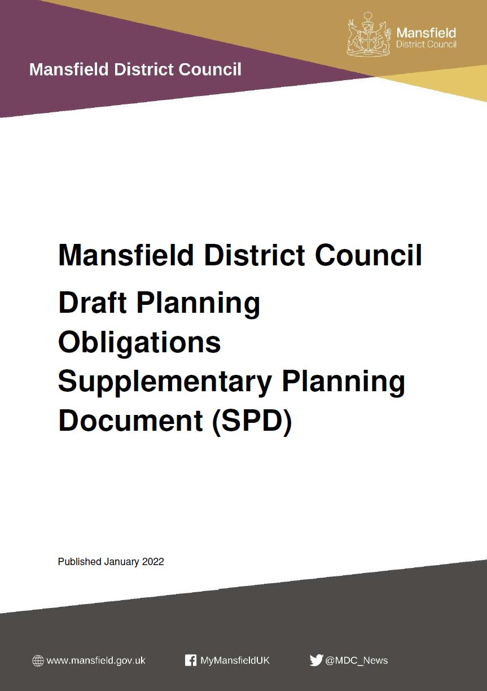

**Consultation Statement**

**July 2022**

Page intentionally blank

|  |  |  |
| --- | --- | --- |
| **Contents** | |  |
|  |  |  |
| **Section** |  | **Page** |
|  |  |  |
| 1.0 | Introduction | 1 |
|  |  |  |
| 2.0 | Who was consulted? | 3 |
|  |  |  |
| 3.0 | How was the consultation undertaken? | 5 |
|  |  |  |
| 4.0 | Who responded? | 10 |
|  |  |  |
| 5.0 | What was said and what is our response? | 12 |
|  |  |  |
| 6.0 | Conclusion | 57 |
|  |  |  |
|  | Appendix A | 59 |
|  |  |  |
|  | Letter to agents and consultees | 59 |
|  |  |  |
|  | E-mail to agents and consultees | 60 |
|  |  |  |
|  | SPD summary table | 61 |
|  |  |  |
|  | Regulation 12, 13 and 35 Consultation Statement | 64 |
|  |  |  |
|  | Consultation poster | 65 |
|  |  |  |
|  | Website text | 66 |
|  |  |  |
|  | Press release | 67 |
|  |  |  |
|  | Mansfield 103.2 article | 69 |
|  |  |  |
|  | Examples of Twitter and Facebook posts | 70 |
|  |  |  |
|  | Example of information about consultation as part of weekly internal MDC staff update | 71 |
|  |  |  |
|  | E-mail to those on Developer Forum mailing list | 72 |

Page intentionally blank

**1.0 Introduction**

**Purpose of the statement**

* 1. It is important that the council engage with the community throughout the preparation of the Local Plan and other planning policy documents. In doing this we need to ensure, we follow the council’s Statement of Community Involvement (SCI)[1] and the Regulations, governing the production of supplementary planning documents (SPDs).[2]

1.2 In this case, we were consulting on our Draft Planning Obligations Supplementary Planning Document (SPD). This consultation took place for six weeks between 31 January 2022 and 14 March 2022.

1.3 This statement explains how we consulted and how we have taken the views of consultees into consideration during the preparation of the Planning Obligations SPD.

**Planning Obligations SPD**

1.4 Planning obligations (also known as Section 106 Agreements or 'planning gain') are legal agreements between the landowner and the council (and any other relevant parties) and are used to overcome any negative impacts of a development or to control the nature of a development.

1.5 The SPD sets out guidance for developers about the obligations which the district council, or in the case of health, the Clinical Commissioning Group (CCG) may seek e.g. for open space, sports pitches, public realm / art public health and how any financial obligations will be calculated. It will be used when the district council consider planning applications within the Mansfield district.

1.6 Nottinghamshire County Council may also seek obligations for things such as transport, libraries and education. The SPD provides a link to the county councils website where developers can find out further information about these and which are set out in the county council’s Developer Contributions Strategy.

**Structure of this Statement**

1.7 The structure of this statement is as follows:

* **Section 2** gives details on who was consulted including the list of specific and general consultation bodies,
* **Section 3** sets out how the consultation was undertaken,
* **Section 4** outlines who responded including the chosen response methods,
* **Section 5** provides a summary of the main issues raised and our response,
* **Section 6** provides a conclusion to the consultation, and
* **Appendix A** provides examples of the various consultation material including letters / emails, press release, and social media posts promoting the consultation.

**2.0 Who was consulted?**

2.1 We sent notifications, either electronically or by post, to 2,764 individuals and organisations registered on the local plan database including the specific and general consultation bodies that are set out in tables 1 and 2 below. This explained the purpose of the consultation event and invited representations on the draft SPD.

**Table 1 -** **Specific consultation bodies:**

|  |  |
| --- | --- |
| Arqiva | Mansfield & Ashfield Clinical Commissioning Group |
| Ashfield District Council | Mansfield and Ashfield Strategic Partnership |
| Bassetlaw District Council | Mobile UK |
| Bolsover District Council | N Power |
| BT Plc | National Grid Property |
| Chesterfield Borough Council | Natural England |
| Clipstone Parish Council | Network Rail |
| Coal Authority | Newark & Sherwood District Council |
| Cuckney Parish Council | NHS Property Services |
| Defence Infrastructure Organisation | North East Derbyshire District Council |
| Department for Transport | Nottingham City Council |
| Derbyshire County Council | Nottinghamshire County Council |
| E.ON Central Networks | Nottinghamshire Healthcare NHS Foundation Trust |
| E.ON Energy Ltd | Nottinghamshire Fire & Rescue Service |
| East Midlands Councils | Nottinghamshire Police and Crime Commissioner |
| East Midlands Trains | Nottinghamshire Police |
| Edwinstowe Parish Council | O2 UK Ltd |
| Environment Agency - Lower Trent Area | Perlethorpe-cum-Budby Parish Meeting |
| Gedling Borough Council | Rainworth Parish Council |
| Health & Safety Executive | Rufford Parish Council |
| Highways England | Severn Trent Water Ltd |
| Historic England | Severn Trent Water Ltd. (Mansfield) |
| Homes England | Sherwood Forest Hospitals NHS Trust |
| Home Builders Federation | Shirebrook Town Council |
| Hutchison 3G UK Ltd | Vodafone Ltd |
| Kings Clipstone Parish Council | Warsop Parish Council |

**Table 2 - General consultation bodies:**

|  |  |
| --- | --- |
| Albert Street Residents Association | Mansfield 2020 Ltd |
| Alzheimer’s Society | Mansfield Business Improvement District (BID) |
| Ancient Monuments Society | National Gypsy Traveller Federation |
| APTCOO | National Federation of Gypsy Liaison Groups |
| Ashfield Links Forum | National Farmers Union |
| British Horse Society | Nottinghamshire MIND |
| Citizens Advice Bureau | Nottinghamshire Biological and  Geological Records Centre |
| Country Land and Business Association Ltd | Nottinghamshire Wildlife Trust |
| Disability Nottinghamshire | Planning Inspectorate |
| Derbyshire and Nottinghamshire Chamber of Commerce | Royal Society for the Blind (Nottinghamshire) |
| Derbyshire and Nottinghamshire Local Enterprise Partnership | Society for the Protection of Ancient Buildings |
| Derbyshire County Council | Sport England |
| Derbyshire Gypsy Liaison Group | Stagecoach East Midlands |
| Forest Town Community Council | Sure Start Meden Valley |
| fft Friends Families and Travellers | Sure Start Ravensdale |
| Groundwork Creswell, Ashfield & Mansfield | The Woodland Trust |
| Health & Safety Executive |  |

**3.0 How was the consultation undertaken?**

3.1 A number of consultation methods were used in the preparation of the Planning Obligations SPD to invite people’s views and comments on it. The list below sets out the details of the methods of engagement used.

**Pre-consultation engagement**

3.2 In developing the Planning Obligations SPD there were internal consultations carried out with other departments / teams at the district council. This included Development Management, Technical Support, Parks and Open Space, Urban Regeneration (to discuss public art / public realm) and Legal Teams. In addition, discussions were held with NHS Nottingham and Nottinghamshire Clinical Commissioning Group (CCG) and NHS Rushcliffe CCG to discuss the nature of obligations for health and how these would be calculated.

**Statutory requirements**

3.3 There is a statutory requirement to consult on the content of a SPD[3]. To meet the requirements of the regulations the following was undertaken:

**Consult with specific and general consultation bodies**

3.4 Consultation was undertaken with the specific and general consultation bodies recorded in the local plan database. All organisations were sent a letter either electronically or by post. This included details about the consultation, how to submit comments on the draft SPD, the timescales for making comments and to whom they should be submitted. There was also a link to the relevant webpage, (<https://mansfield-consult.objective.co.uk/portal/spd/planningobligations>), where the draft SPD and online questionnaire could be viewed. This letter was also emailed / posted to all members of the public on the database, and can be viewed in Appendix A (page 60). As set out in paragraph 2.1, a total of 2,764 people and organisations were contacted using these methods.

**Making copies of documentation available for inspection**

3.5 Copies of the Draft Planning Obligations SPD, paper questionnaires, a summary document, consultation statement setting out how people / organisations could comment on the SPD (including timescales for doing so) along with a poster raising awareness of the consultation were made available to view at the following venues:

* Mansfield District Council - Civic Centre, Chesterfield Road South
* Clipstone Village Library - First Avenue
* Forest Town Library - Clipstone Road West
* Ladybrook Library - Ladybrook Place
* Mansfield Library - West Gate
* Mansfield Woodhouse Library - Church Street
* Rainworth Library - Warsop Lane
* Market Warsop Library - High Street

3.6 A copy of the summary document, the consultation statement and poster can be viewed in appendix A (pages 61 – 63 and 65).

**Website**

3.7 Information about the consultation, including links to a PDF copy of the draft SPD and the summary document along with a link to the Local Plan consultation portal was available to view and download from the council’s website <https://www.mansfield.gov.uk/planning-policy/consultation-planning-policies-1> The document was also available on the Local Plan consultation portal to allow people to comment online. A screenshot of the webpage can be viewed in appendix A on page 66.

**Press Release**

3.8 A press release was issued by the district council on 31 January 2022 to 124 recipients. This gave details of the consultation period and where copies of the document were available for viewing. A copy of the press release is included in Appendix A (pages 67 and 68).

3.9 The press release generated three stories on Mansfield radio and two in the Chad (local newspaper) and these can be viewed in the links below. The online reach for these is calculated at 723,712 according to statistics collected by the council’s communications platform Vuelio. A copy of the article that appeared on the Mansfield radio website (103.2) can be viewed in appendix A (page 69).

* <http://www.mansfield103.co.uk/blogs/public-asked-for-views-on-planning-process/>
* <https://www.chad.co.uk/news/people/views-wanted-on-the-future-of-mansfields-planning-approval-process-3550686>

**Social Media**

3.10 The council’s Facebook page ‘Mansfield District Council - My Mansfield’ was updated on four occasions during the consultation period to notify people about the consultation and provide them with links to the consultation portal. Graph 1 below shows the number of people reached on each of these occasions:

3.11 Further details about these posts are set out in the table below.

**Table 3 – Planning Obligations SPD Consultation Facebook Data**

|  |  |  |  |  |
| --- | --- | --- | --- | --- |
|  | **8th February** | **16th February** | **24th February** | **4th March** |
| **Post impressions** | 5,019 | 5,783 | 6,979 | 10,739 |
| **Post reach** | 4,451 | 5,245 | 6,689 | 9,530 |
| **Post engagement** | 254 | 322 | 812 | 1,101 |
| **Reactions** | 0 (zero) | 1 like | 0 (zero) | 5 likes |
| **Comments** | 0 (zero) | 1 | 0 (zero) | 0 (zero) |
| **Link clicks** | 46 | 9 | 5 | 95 |
| **Shares** | 14 | 4 | 2 | 35 |
| **Other clicks** | 162 | 290 | 670 | 864 |

3.12 Four Tweets were also sent via the council’s Twitter account (@MDC_News) to help raise awareness of the consultation. Details about the number of impressions for each of the posts is set out in graph 2 on page 8 below.

3.13 Some examples of the Facebook and Twitter posts can be seen in appendix A (page 70).

**Other Engagement**

3.14 To help raise awareness of the consultation within the district council, information was included as part of the regular email updates that are circulated to staff. Examples of these can be seen in appendix A (page 71).

3.15 In addition to all of the above, some specific, more targeted engagement was undertaken. Firstly, an individual meeting was held with NHS Nottingham and Nottinghamshire Clinical Commissioning Group (CCG) to discuss the district councils proposed approach to planning obligations and the content of the section of the SPD that covers obligations for health infrastructure. A meeting with colleagues from Nottinghamshire County Council followed this, the purpose of which was to discuss the proposed approach to planning obligations, in particular how the SPD deals with those planning obligations which may be sought by the county council and which are set out in its Developer Contributions Strategy[4]

3.16 Finally, of the 2,764 people and organisations referred to in paragraph 3.4 above, emails were sent to those people and organisations who are on the district council’s Developers Forum mailing list (135 recipients) inviting them to one of two workshops about the SPD which were being held on the 9 and 15 February. An example of this email can be viewed in appendix A (page 72). Unfortunately, the take up for this was very disappointing with only one organisation replying to confirm that they would like to attend. Despite this, officers from the district council’s Planning Policy and Development Management teams still went ahead with the event. This gave the district council the opportunity to run through a presentation about the various aspects of the SPD and the organisation who attended was able to ask questions that they had about the document.

**4.0 Who responded?**

4.1 From those notified about the consultation on the Planning Obligations SPD, 14 people / organisations responded. Graph 3 below shows the breakdown of respondent type. As can be seen, the majority of responses were submitted by the general public and statutory consultees.

4.2 Graph 4 shows the method by which these responses were made.

4.3 Finally, in terms of the questions answered, the most popular was question 15 (Do you have any other comments on the SPD?) with 10 responses. It should be noted that in some cases, respondents answered part a) of the question but not part b). In most cases, part b) was asking respondents to give their reasons for their response to part a) of a question. Graph 5 below shows the number of responses to each question, or which could be attributed to each question.

**5.0 What was said and what was our response?**

5.1 A summary of the comments received during the consultation period and our response is set out in the table below. This includes any changes that are proposed to be made to the SPD before the district council adopts it.

| **Organisation details (if applicable)** | **Comment ref** | **Question** | **Officer summary** | **MDC response to comment / Action** |
| --- | --- | --- | --- | --- |
| **Q1a - Do you agree with the purpose of the SPD and what it will seek to achieve in terms of infrastructure delivery in the district?**  **Q1b – Reason** | | | | |
| N/A | POSPD/1 | Q1a&b | Agrees with the purpose of the SPD. Making an obligation on builders / developers is considered to be sound | Noted - No further action required |
| N/A | POSPD/2 | Q1a&b | Consultee does not agree with the purpose of the SPD. It attempts to define specific amounts to the area of developments proposed. This implies that development is the same and cause the same problems other than being brownfield / greenfield. They are not the same and policy should be led by economic assessment of each proposal. Gives examples of differences between greenfield and brownfield. The former will add pressure on existing infrastructure. However, brownfield may not as the demands of the proposal may be same as previous use and could actually improve situation. S106 costs could imbalance development of brownfield site, which has complex needs to bring it forward. Examples are given. Dealing with these issues would improve the district, not add problems. The word problems needs to be defined. | It is acknowledged that every development will be different and that the impacts will vary. The district council along with others who may seek obligations e.g. county council, Clinical Commissioning Group (for health obligations) will assess the impacts on a case-by-case basis, including viability considerations, and identify what, if any planning obligations are required.  The SPD seeks to apply a consistent and transparent approach to planning obligations. It sets out how obligations will be calculated. This will allow applicants / agents to factor this in to their wider costs of developing their site or where appropriate, the amount that they pay when purchasing land for development.  Where an applicant has concerns about the impact that the obligations sought may have on the ability to deliver their scheme they can submit a viability assessment. The district council’s approach to viability, including reference to review and clawback mechanisms, is set out in paragraphs 3.28 – 3.39 of the SPD. There is also information about how this should be addressed during the planning application process in paragraphs 3.4 and 3.11 – 3.13. |
| N/A | POSPD/2 | Q1a&b | Economic impacts and assessment of impacts should be used to define the S106 contributions. | Noted – See response to previous comment above. |
| Nottinghamshire County Council | POSPD/6 | Q1&b | Consultee agrees with the purpose of the SPD. Considers that the document clearly sets out what infrastructure will be delivered by the District and County Councils and the importance of planning obligations in the process. By referring to the County Council's Developer Contributions Strategy, the District Council is endorsing the County Council's approach to obligations. This is welcomed. | Noted - No further action required |
| Sport England | POSPD/7 | Q1&b | Consultee agrees with purpose of the SPD. | Noted - No further action required |
| Sport England | POSPD/7 | Q1&b | Consultee notes that increase in population will generate greater need for sports facilities. If need not met, this will place pressure on existing facilities. Confirms that Sport England seeks to ensure that the development meets any new sports facility needs arising as a result of the development. | Noted – Part 7 of the Draft SPD sets out the proposed approach for seeking contributions for green infrastructure, community open spaces, playing pitches and allotments. In addition, Local Plan policy IN4 seeks to enhance community open space and outdoor sports provision. |
| **Q2a - Are there any other types of infrastructure for which you think obligations should be sought?**  **Q2b – Reason** | | | | |
| N/A | POSPD/1 | Q2a&b | Consultee feels that obligations for other infrastructure should be sought namely roads / road safety, internet infrastructure (funding towards national fibre rollout), Environmental project support (funding projects to update older housing with modern environmental heating / isolation etc.) | The county council may seek obligations / other approaches to fund and secure highway infrastructure. This is confirmed in paragraph 1.12 and section 9 of the SPD. In addition, a direct link to the County Council’s Developer Contributions Strategy is provided in section 4, table 1 (page 24). No further action required.  In terms of contributions towards other infrastructure, this can only be sought where reference to doing this is made within the local plan and it is reasonable and necessary to do so.  In terms of upgrading older housing, this is not something that would be addressed through planning obligations. In addition, there may be other funding sources / projects available that could be used to help deliver these improvements. |
| N/A | POSPD/2 | Q2a&b | Consultee considers that there are other types of infrastructure that should be sought. Contributions should be used for conservation areas and smaller projects where there is no regular income to allow them to be managed.  Should look to provide flood alleviation due to increase in hard standing and run off. This should be balanced against on site solutions.  Contributions from large-scale residential development should be used for village centres and nearby hubs.  Provision of green spaces are only worth having if they are safe. Mansfield Way is not considered safe due to motorbikes and anti-social behaviour. Obligations should be used to make safer via CCTV and wardens. | Whilst acknowledging its importance, policies within the Local Plan do not include any references to seeking planning obligations for the historic environment / conservation areas. In addition, the Whole Plan Viability Assessment, which was undertaken as part of the production of the Local Plan, did not take into account possible contributions for the historic environment / conservation areas and it is not identified in the adopted Local Plan. Supplementary Planning Documents are not permitted to introduce new policy therefore, at this time, it is not considered possible to seek such contributions.  Local Plan policies CC2 (Flood risk) and CC3 (Sustainable drainage systems) set out the policy approach for such issues. In addition, local plan policy IN10 refers to the incorporation of sustainable urban drainage paving systems where appropriate. The Council will be producing a SuDS SPD.  Noted – Depending on the size of the development, the applicant, as part of their scheme, may include new centres. Depending on the obligations sought by consultees, new and improved facilities may be provided within existing centres. The location of such provision will be set out within the Section 106 legal agreement.  Accept that green spaces have to be safe. Policy P2 of the Local Plan seeks to deliver safe, healthy and attractive development. Where new and improved open space is required and evidence of need for such supporting measures can be provided due to the impact of new development, the costs of these could be included as part of the request for the obligation. |
| N/A | POSPD/2 | Q2a&b | Greenfield developments are using up electricity capacity. This would not be the case if development had not taken place. Concern expressed about costs that Western Power charging for improvements to existing sites due to development of greenfield sites. Consultee feels that these costs should come from S106 monies and be weighted on greenfield sites. | Noted – Whilst acknowledging that the development of a greenfield site has had an impact on the infrastructure capacity, on a broader scale development of brownfield sites can also affect infrastructure capacity, especially where the previous and new uses are different.  MDC can only seek obligations that meet the 3 statutory tests that are set out in paragraph 2.4 of the SPD. MDC do not consider that it is possible or appropriate to include wording within the SPD that, in addition to mitigating the impact of their own scheme, requires greenfield sites to resolve the issues of existing users / developments.  In terms of the costs being charged by Western Power, this is not something that the district council has any control over. |
| Nottinghamshire County Council | POSPD/6 | Q2a | Consultee does not think there are any other types of infrastructure for which obligations should be sought. | Noted - No further action required |
| Sport England | POSPD/7 | Q2&b | The list of infrastructure which may be sought at paragraph 1.10 does not include reference to community facilities, especially sports facilities. | Noted – Whilst the list of infrastructure does not include reference to sports facilities, in section 7 the table on playing pitches confirms that contributions to improve existing pitches may be sought and that these should be in line with the needs of the community as set out in paragraphs 9.28 and 9.29 of the adopted local plan.  Where larger residential schemes come forward, the applicant may look to provide community facilities as part of the development. |
| Sport England | POSPD/7 | Q2&b | Consultee notes that the Council do not have an up to date Built Sports Facilities Strategy. Whilst the consultee does not disagree with the approach, given the evidence is considered out of date the request for contributions could be challenged. Up to date information is not available to understand if:   1. Existing playing fields generally and specific sports facilities have the capacity to meet the demand identified? 2. Whether investment in existing facilities would enable them to meet some or all of the demand? 3. What on site provision or new facilities off site are required to meet the demand that cannot be met elsewhere? | Noted – As stated elsewhere, there will be an opportunity to update such strategies as part of the local plan review. In the meantime, the district council will use the most up to date information that is available to help assess if existing facilities can meet the demand arising from new development. |
| Sport England | POSPD/7 | Q2&b | Due to the date it was produced, the Council's Playing Pitch Strategy (PPS) is no longer considered robust. The PPS has not been kept up to date and whilst the addendum is from 2018, the baseline information dates from the original PPS (2016). Consultee recommends full review of the PPS. | Noted – The Local Plan review will provide the opportunity to undertake a review of the Playing Pitch Strategy, along with other elements of the evidence base. Until that time, the district council will have to use the most up to date information that is available to it. |
| Sport England | POSPD/7 | Q2&b | Whilst Sport England do not disagree with the approach set out, contributions requested could be subject to challenge due to the evidence to support them being out of date. | Noted – See response to consultee’s previous comment above. |
| Sport England | POSPD/7 | Q2&b | The reference to and use of the Sport England calculator has limited value if the local derived information to support it is out of date. | Noted – See response to consultee’s previous comment above. |
| Sport England | POSPD/7 | Q2&b | Consultee refers to concerns that have been made by the football and cricket governing bodies regarding playing provision in the district. Also expresses concern about maintenance. | Noted – As part of the review of the local plan there will be an opportunity to review the existing Playing Pitch Strategy. In terms of maintenance, if evidence of the need for a contribution towards this can be demonstrated because of the impact of development a contribution may be sought and included in the S106 legal agreement as required, subject to viability and other planning considerations. |
| Sport England | POSPD/7 | Q2&b | Consultee would welcome the opportunity to review and update the PPS. | As referred to above, the Local Plan review will provide the opportunity to update the Playing Pitch Strategy. The assistance of Sport England and the national governing bodies in helping the district council to undertake this work is both welcomed and supported. |
| **Q3a - Do you have any comments on the various mechanisms for securing infrastructure within the Mansfield district?**  **Q3b – Reason** | | | | |
| N/A | POSPD/1 | Q3a | Consultee has no comment on the various mechanisms for securing infrastructure within the Mansfield district | Noted - No further action required |
| N/A | POSPD/2 | Q3a&b | Definition of the difference between greenfield and brownfield is not set out in the SPD. | Accepted – Reference to greenfield and brownfield land (also known as previously developed land) is within table 1 on page 22 of the Draft SPD (summary of planning obligations) in the affordable housing section. A link has been inserted so that readers have access to the definitions, which are within Appendix 2 (glossary of terms) of the Adopted Local Plan. |
| N/A | POSPD/2 | Q3a&b | Consultee does not agree with the formulas given as does not take account of the economic assessment of each site. | Noted – The use of formulae to calculate the planning obligations that may be sought provides a consistent and transparent approach and one that is used across the country.  It is acknowledged that economics of each site will be different. Where an applicant has concerns about the impact that the obligations sought may have on the ability to deliver their scheme they can submit a viability assessment. The district council’s approach to viability, including reference to review and clawback mechanisms, is set out in paragraphs 3.28 – 3.39 of the SPD. There is also information about how this should be addressed during the planning application process in paragraphs 3.4 and 3.11 – 3.13. |
| N/A | POSPD/2 | Q3a&b | During local plan consultation, was told that did not need to discuss mitigation costs applied to Ratcher Hill employment area. | Noted – This level of discussion would typically take place at the planning application stage |
| N/A | POSPD/2 | Q3a&b | Should be consultative exercise that reflects importance of good working and ongoing relationships with council and landowner. Developers who do not have ongoing relationship with site once developed should be required to put something back via S106 monies. Different situation where companies have ongoing relationship with council and longer term interests and costs associated with this. Should be better interactions early in the process by the Planning Policy Team. This is more professional and reasonable to previous approaches that have taken. Has lost trust of department due to interactions had with the team during the Local Plan process. | Noted – In identifying possible sites for development within the local plan the district council will seek to work with landowners and their agents to identify what infrastructure will be required and how this will be delivered e.g. via planning obligations and any viability implications. This will also take place as part of the pre-application / formal planning application stages during which infrastructure providers such as the district council, county council and Clinical Commissioning Group will identify the planning obligations that may be required. |
| Nottinghamshire County Council | POSPD/6 | Q3a&b | Consultee feels that the different roles of planning obligations conditions (including those relating to highways) are clearly set out and corresponds with that set out in the County Council's Developer Contributions Strategy. | Noted - No further action required |
| **Q4a - Do you agree with the proposed approach to negotiating and completing planning obligations?**  **Q4b – Reason** | | | | |
| N/A | POSPD/1 | Q4&b | The consultee agrees with the proposed approach to negotiating and completing planning obligations. No reasons given. | Noted - No further action required |
| N/A | POSPD/2 | Q4a&b | Consultee cannot see an approach within the SPD so does not know what question means. | The approach for negotiating and completing planning obligations is set out in section from paragraphs 3.3 – 3.27 of the SPD. This goes from the start of the application process through to determination. It also includes information about the thresholds that will be used when seeking obligations along with the approach that will be taken when land for infrastructure is provided instead of / alongside a financial contribution. Information about the preparation and signing of legal agreements is set out in paragraphs 3.40 – 3.44.  Question 4 seeks to ascertain whether consultees agree with everything that is set out within these paragraphs.    No further action required. |
| N/A | POSPD/2 | Q4a&b | Consultee re-emphasises that negotiation is a two way process. The mitigation in the local plan added in the middle of the process, did not recognize the scale of development and proposed improvements to a site that would have no impact whatsoever from the development. This is because the size of buildings aren't yet defined. | Acknowledge that negotiation is a two way process. In terms of mitigation that may be required, this can be confirmed once the size of buildings is known and planning applications are submitted. |
| N/A | POSPD/2 | Q4a&b | Monies should be aimed at or next to area where development occurs.  Needs to be recognition that developers could mitigate site themselves to reduce S106 needs. | Agree – Paragraph 2.4 of the SPD refers to the 3 statutory tests that should be met when seeking planning obligations. The second of these says they should “be directly related to the proposed development”. The Section 106 agreement will set out where obligations will be spent.  There may still be circumstances when obligations are still required. The production of this SPD will help provide a guide to applicants / agents as to what these obligations may be and how they will be calculated. |
| N/A | POSPD/2 | Q4a&b | Reference is made to consultees site and road infrastructure that council thought was coming through the site. Was seen as opportunity to get monies for Oak Tree. Road is not happening therefore no impact from consultees site. There will be impacts as result of development to north of former quarry. | The comment about the consultees’ site and reference to the road is noted.  In terms of the site to the north of the former quarry, this refers to the site identified within Policy SUE2 of the adopted local plan (Land off Jubilee Way). It is acknowledged that the site will have impacts.  The local plan policy identifies a number of assessments that will be required to help identify any such impacts. Further information about the potential impacts of this site and means of addressing these will be provided as part of any planning application that may be submitted for the site.  In addition, the tables on pages 175 and 176 of the Infrastructure Delivery Plan (IDP) that was produced alongside the local plan identifies an infrastructure cost schedule for the various local plan sites. These may be subject to change should a planning application be submitted for the site. |
| N/A | POSPD/2 | Q4a&b | Does not consider negotiation has taken place. | Noted – As part of the review of the local plan and any planning applications that may be submitted for sites, the district council will seek to work with landowners and their agents to identify the infrastructure that may be required and the best ways for ensuring this is delivered. |
| Nottinghamshire County Council | POSPD/6 | Q4a&b | Paragraph 2.8 of the SPD clearly sets out the approach for obligations that may be sought by the County Council and the fact that NCC will be party to negotiating such obligations and their subsequent enforcement. This approach is welcomed. | Noted - No further action required. |
| Nottinghamshire County Council | POSPD/6 | Q4a&b | Consultee notes that NCC may seek to recover its reasonable legal costs that are incurred in agreeing planning obligations. Suggests that a note to this affect be included in paragraph 3.14 of the SPD. | Accepted – Additional wording has been added to paragraph 3.14. |
| Nottinghamshire County Council | POSPD/6 | Q4a&b | Consultee agrees that information about requirements that are submitted at pre-application stage may be subject to change and that applicants should be notified of this. In addition, agree it may not be possible to provide information about contributions sought at this stage but NCC will provide indicative guidance were possible. | Noted - No further action required. |
| **Q5a - Do you agree with the thresholds that will be used when seeking to secure planning obligations to mitigate the impact of development?**  **Q5b - Reason** | | | | |
| N/A | POSPD/1 | Q5a&b | Consultee does not agree with the proposed thresholds for seeking obligations. Thinks that they are too high and will encourage developers to put in lots of applications for small schemes below the threshold. Considers that the threshold should be one. | Paragraph: 023 Reference ID: 23b-023-20190901 of the Planning Practice Guidance for planning obligations (<https://www.gov.uk/guidance/planning-obligations>) sets out when planning obligations can be sought. Whilst this provides a low level threshold there will be some types of infrastructure where the impact will only be felt at a higher level of development.  The district council has worked with colleagues and agencies such as the Clinical Commissioning Group to identify reasonable and realistic thresholds for seeking obligations and these are included in the tables for the various types of infrastructure within part 2 of the SPD    The concern about developers putting in schemes below the threshold is noted. Where a number of such sites come forward that adjoin each other, it may be possible to consider the cumulative impacts on infrastructure. However, this will be on a case-by-case basis. The district council are unable to seek contributions on individual sites that come forward and which are below the nationally agreed threshold for seeking obligations. |
| N/A | POSPD/2 | Q5a&b | Consultee does not agree with cap on costs were large scale, greenfield developments have significant impacts on infrastructure and environment. Planning Policy team will say does not need to look at positives of developing a brownfield side compared to the negative. | The references to amounts per dwelling have been removed from all sections of the SPD whilst the Whole Plan Viability Appraisal will be updated as part of the Local Plan review. |
| Nottinghamshire County Council | POSPD/6 | Q5a&b | Consultee agrees with the thresholds for seeking planning obligations as set out in paragraph 3.24. | Noted – There will be some types of infrastructure where the impact will only be felt at a higher level of development.  The district council has worked with colleagues and agencies such as the Clinical Commissioning Group to identify reasonable and realistic thresholds for seeking obligations and these are included in the tables for the various types of infrastructure within part 2 of the SPD  No further action required. |
| Nottinghamshire County Council | POSPD/6 | Q5a&b | Reference to provision of land as in-kind contribution is agreed. | Noted - No further action required. |
| Nottinghamshire County Council | POSPD/6 | Q5a&b | Requests that reference to NCC "Planning Obligations Strategy" be amended to "Developer Contributions Strategy" | Agreed – As requested, all references to the county councils Planning Obligations Strategy have been amended to say Developer Contributions Strategy. Links to the document on the county councils website have also been updated. |
| **Q6a - Do you agree with the district council’s proposed approach to viability?**  **Q6b – Reason** | | | | |
| N/A | POSPD/1 | Q6a&b | Consultee agrees with the district council's approach to viability. No reasons given | Noted - No further action required. |
| N/A | POSPD/2 | Q6a&b | Consultee questions where the approach to viability is set out. | The district councils approach to viability, including reference to review and clawback mechanisms, is set out in paragraphs 3.28 – 3.39 of the SPD. |
| N/A | POSPD/2 | Q6a&b | Expresses concerns about questions that have no clear reference to relate back to. | Accepted – In the future, the district council will seek to ensure that questions will have paragraph numbers to refer back to e.g. Do you agree with the district council’s proposed approach to viability, as set out in paragraph 3.28 through to paragraph 3.39? |
| Nottinghamshire County Council | POSPD/6 | Q6a&b | Consultee supports the approach that where reduced / revised obligations secured due to viability, the priorities for infrastructure will be determined by MDC having given due consideration to comments from infrastructure providers.  Also requests that they (NCC) be notified where such circumstances arise so they can provide guidance on their priorities / apportionments of contributions. | Noted - No further action required.  Accepted – This is something that will be undertaken by the planning application case officer should the need arise. |
| Nottinghamshire County Council | POSPD/6 | Q6a&b | Consultee agrees with the use of viability reviews where reduced obligations are secured. | Noted - No further action required. |
| N/A | POSPD/10 | Q6b | Need for the council to work with developers regarding the issue of viability. Issues can often be overcome by being flexible, prioritising requirements and phased approach to payment of contributions. Due to viability, may be need for phased payments against trigger points within development. | Agreed – The issue of viability, including the need to pick up on any such issues as early as possible within the application process and reference to review and clawback mechanisms, is addressed in various paragraphs within the SPD including 3.11 – 3.13 and 3.28 – 3.39.  Paragraph 3.46 confirms that triggers for the payment of contributions will be considered on a case-by-case basis. It also confirms that payment on the anniversary of commencement, occupation or staged payment may be acceptable so long as this secures infrastructure when it is needed and where it does not affect the viability of the scheme. |
| **Q7a - Do you agree with district council’s proposed approach to payment of contributions?**  **Q7b – Reason** | | | | |
| N/A | POSPD1 | Q7a&b | Consultee does not agree with the proposed thresholds for seeking obligations. Thinks that they are too high and will encourage developers to put in lots of applications for small schemes below the threshold. Consultee considers that the threshold should be one. | Paragraph: 023 Reference ID: 23b-023-20190901 of the Planning Practice Guidance for planning obligations (<https://www.gov.uk/guidance/planning-obligations>) sets out when planning obligations can be sought. Whilst this provides a low level threshold there will be some types of infrastructure where the impact will only be felt at a higher level of development.  The district council has worked with colleagues and agencies such as the Clinical Commissioning Group to identify reasonable and realistic thresholds for seeking obligations. These are included in the tables for the various types of infrastructure within part 2 of the SPD  The concern about developers putting in schemes below the threshold is noted. Where a number of such sites come forward that adjoin each other, it may be possible to consider the cumulative impacts on infrastructure.  However, this will be on a case-by-case basis. The district council are unable to seek contributions on individual sites that come forward and which are below the threshold for which contributions may be sought. |
| N/A | POSPD1 | Q7a&b | The contributions being sought are considered to be too low when considered against profits developers make. | Noted – The calculation of contributions is based on the most up to date information possible.  Following comments received from other consultees, the amount per sq.m to calculate the health contribution has been increased to £5,000m2 This is to reflect more realistic costs of provision.  It will be possible to amend the SPD and review the Local Plan to take account of any changes that may occur to the approaches / formulae for calculating contributions. |
| N/A | POSPD/2 | Q7a&b | Consultee does not agree with approach to payment of contributions. Does not agree with having a set model; should be based on an economic assessment. | There is no set model for the payment of contributions that will be applied to all applications where contributions are required. Paragraph 3.46 of the SPD confirms that triggers will be considered on a case-by-case basis. It also confirms that payment on the anniversary of commencement, occupation or staged payment may be acceptable so long as this secures infrastructure when it is needed and where it does not impact on the viability of the scheme. No change to the SPD required. |
| Nottinghamshire County Council | POSPD/6 | Q7a&b | Consultee agrees with trigger points and clawback periods especially the ten-year period in paragraph 3.48, as this will allow NCC to pool contributions for highways and education projects in its Developer Contributions Strategy. | Noted - No further action required |
| Nottinghamshire County Council | POSPD/6 | Q7a&b | Consultee agrees with content of paragraph 3.50, which states that obligations secured for NCC infrastructure will be paid direct to the County Council when triggers are reached. | Noted - No further action required |
| **Q8a - Do you agree with the district council’s proposed approach to indexation?**  **Q8b – Reason** | | | | |
| N/A | POSPD1 | Q8a&b | Consultee agrees with approach to indexation subject to the amounts being sought are correct. Consultee feels that they (the amount of contributions) are too low. | Noted – As set out in response to the consultees comment on question 7; the calculation of contributions is based on the most up to date information as possible. It will be possible to amend the SPD to take account of any changes that may occur to the approaches / formulae for calculating contributions. |
| N/A | POSPD/2 | Q8a&b | Consultee does not understand the question. | Indexation will be applied to all planning obligations that are secured. This to reflect the inflation of costs associated with providing infrastructure in the time between a Section 106 legal agreement being signed and the contribution becoming due for payment. There are various types of indexation that can be applied. The approach to indexation is set out in paragraphs 3.49 and 3.50 of the SPD along with the section on health contributions (pages 19 and 20). The question is asking whether consultees agree with this. No further action required. |
| Nottinghamshire County Council | POSPD/6 | Q8&b | Consultee agrees with the approach to indexation. Notes that in some cases, NCC may request indexation based on BCIS All-in TPI as this relates to build costs. Suggests that a note to this effect may be included in the SPD. | Accepted – A new sentence has been added to paragraph 3.50 on page 20 to acknowledge that the county council may seek to use the BCIS All-In Tender Price for obligations, which are secured for county council infrastructure. |
| **Q9a - Do you think there are any other matters that need to be included in this section?**  **Q9b – Reason** | | | | |
| N/A | POSPD/1 | Q9a | Consultee does not think there are any other matters that should be included in the SPD | Noted - No further action required |
| N/A | POSPD/2 | Q9a&b | Consultee re-emphasises that economic impact assessment should lead on any policy. | Noted – See response to consultees comments on questions 1a&b. |
| N/A | POSPD/2 | Q9a&b | States Planning Policy team often say they don't have to communicate or justify things.  Documents developed are too long and not followed through with actions. | This comment does not relate specifically to this consultation but wider issues. The Statement of Community Involvement (SCI) sets out how and when the district council will consult the community on matters relating to Planning Policy and Development Management. The SCI was updated earlier this year and can be viewed at <https://www.mansfield.gov.uk/downloads/file/3048/final-sci-january-2022>  It is acknowledged that some documents which are produced are long. However, it is important that those who may benefit or be affected by the documents content have access to as much information as possible. At the start of part 2 of the Planning Obligations SPD (which commences at page 22), a summary table of planning obligations which may be sought was included and this has been retained. |
| N/A | POSPD/2 | Q9a&b | Should build relationship with landowners, developers and public. This did not occur during production of Local Plan that led to failure to secure employment space that was required. | Noted – The Statement of Community Involvement (see link in response to previous comment) sets out the functions of the planning system. The SCI confirms how landowners, developers and the public can become involved in all matters relating to the production of planning policy documents and the submission / determination of planning applications.  As part of this, the SCI sets out what people can expect from the district council (paragraph 1.13) in relation to both planning policy and development management matters.  No specific amendment required to the Planning Obligations SPD. |
| Nottinghamshire County Council | POSPD/6 | Q9a&b | Consultee requests that link to NCC Developer Contributions Strategy on page 24 be updated.  As part of reference to NCC infrastructure on page 24, consultee suggests that there may be merit in listing those for which contributions may be sought. | Accept – The link to the county councils Developer Contributions Strategy has been updated.  Accept – A list of those contributions, which may be sought by the county council, has been added to the summary in table 1 of the SPD (pages 23 and 24). |
| **Q10a - Do you agree with the district council’s approach to obligations for biodiversity net gain?**  **Q10b – Reason** | | | | |
| N/A | POSPD1 | Q10a | Consultee agrees with the district council's approach to biodiversity net gain. No reasons given. | Noted – Having reflected on how the council’s approach to securing planning obligations for biodiversity net gain (BNG) should be set out and taken forward; the council has decided that this will be set out in a separate SPD. Once prepared, this will be subject to a separate period of consultation prior to the document being adopted and used when considering planning applications.  As with obligations for affordable housing and county council infrastructure, the Planning Obligations SPD will note that obligations for biodiversity net gain will be sought with a separate reference to the SPD that contains this information. |
| N/A | POSPD/2 | Q10a&b | Consultee does not agree with approach to biodiversity net gain. Feels that can be achieved better by undertaking an audit and through discussions / collaboration with private sites rather than just to a desktop exercise that does not consider how it all links up. | Noted – As set out above; the council’s approach to obligations for biodiversity net gain will now be set out in a separate SPD. This will include clarification on how it will be assessed and delivered. |
| Nottinghamshire County Council | POSPD/6 | Q10b | Consultee has no comments on this question. | Noted - No further action required. |
| **Q11a - Do you agree with the district council’s approach to obligations for green infrastructure, community open space, playing pitches and allotments?**  **Q11b – Reason** | | | | |
| N/A | POSPD1 | Q11a | Consultee agrees with the district council’s approach to obligations for green infrastructure, community open space, playing pitches and allotments. No reasons given. | Noted - No further action required |
| N/A | POSPD/2 | Q11a&b | Consultee agrees with approach to green infrastructure, community open space, playing pitches and allotments. However refers to previous comments. Consultee finds reference to allotments to be strange taking account of monies held by Allotments for the Poor, which was before allotments sold off. | The support to the approach to this type of infrastructure is noted and welcomed.  In terms of allotments, the monies held by Allotments for the Poor is not relevant to the impact that development may have on the need for such facilities. No further action required. |
| Nottinghamshire County Council | POSPD/6 | Q11b | Consultee has no comments on this question. | Noted - No further action required |
| Historic England | POSPD/9 | Q11b | Whilst section 7 of the SPD refers to heritage settings and assets, there is no specific reference to contributions for the historic environment. Consultee recommends that part 2 of the SPD be amended to include reference to the historic environment and that, where appropriate, contributions are required towards protection, conservation and enhancement of the historic environment, heritage assets and their settings. | Whilst acknowledging its importance, policies within the Local Plan do not include any references to seeking planning obligations for the historic environment. In addition, the Whole Plan Viability Assessment, which was undertaken as part of the production of the local plan, did not take into account possible contributions for the historic environment and it is not a requirement of Local Plan policy. Supplementary Planning Documents are not permitted to introduce new policy therefore; at this time, it is not possible to seek such contributions. It can be considered as part of the Local Plan review. |
| **Q12a - Do you agree with the district council’s approach to obligations for health?**  **Q12b – Reason** | | | | |
| N/A | POSPD1 | Q12a&b | Consultee does not agree with the costs of the obligations, seen as too low. | Following comments from NHS Property Services Limited, the cost per m2 for extensions has been updated and increased to £5,000m2. This is to reflect more realistic costs of provision. It should be noted that the increased cost could potentially have implications for viability. The district council will deal with this on a case-by-case basis until it reviews the Local Plan and updates its viability evidence. |
| N/A | POSPD/2 | Q12a&b | Consultee agrees about seeking contributions for health. | Noted – Agreement with this is welcomed |
| Nottinghamshire County Council | POSPD/6 | Q12b | Consultee has no comments on this question. | Noted - No further action required |
| NHS Property Services Limited | POSPD/14 | Q12b | Consultee supports mitigation of site-specific impacts of development. This can be in the form of capital cost contribution or delivery of on-site health infrastructure. | Noted – Agreement with this is welcomed. |
| NHS Property Services Limited | POSPD/14 | Q12b | Consultee considers that the £2,700 cost per sq.m which is referred to in the SPD is to low and unlikely to take account of true cost of delivery. As will be undertaken by public sector, consultee considers should include element of optimism bias as this is standard rate for public sector build projects. | Accepted – A separate email on this point, outside of the consultation, has been received from NHS Nottingham and Nottinghamshire Clinical Commissioning Group (CCG). This included a higher figure. Following clarification as to what the proposed cost m2 includes and to ensure that it covers both the elements that NHS Property Services Limited request and to reflect the more realistic costs of provision, a higher cost per m2 (£5,000) has been inserted into the SPD.  It should be noted that the increased cost could potentially have implications for viability. The district council will deal with this on a case-by-case basis until it reviews the Local Plan and updates its viability evidence. |
| NHS Property Services Limited | POSPD/14 | Q12b | Consultee comments on the proposals for index linking contributions. These are currently based on the Retail Price Index. Whilst supports use of indexation, considers that it should be based on changes to build costs. On this basis should be based on BCIS All-In Tender Price Indexation. | Consultees support for the use of indexation is welcomed.  The request to amend the indexation used is accepted. The SPD has been amended to make reference to the BCIS All-In Tender Price Index (pages 19 and 34). |
| NHS Property Services Limited | POSPD/14 | Q12b | Consultee refers to the maximum amount that will be sought per dwelling (£1,057) for health and public realm / art. Feels that this is artificial and if applied would result in insufficient mitigation being provided. As part of this, consultee notes that this is based on Whole Plan Viability Assessment, which was undertaken in 2018 that is out of date. States that since Local Plan adopted average prices increased by 24%. Consultee states that the cap on contributions for health and all other obligations should be removed from the SPD. | The district council’s position is that it will seek policy compliant contributions.  Where applicants feel that the obligations sought may have an impact on the deliverability of their scheme, they can submit a viability assessment. This will be subject to independent review. The applicant will meet the costs of undertaking this review. The district councils approach to viability, including reference to review and clawback mechanisms, is set out in paragraphs 3.28 – 3.39 of the SPD.  Where it is demonstrated that viability is an issue, it may not be possible to secure all obligations that are required or the amount secured may be less than that requested.  The references to amounts per dwelling have been removed from all sections of the SPD whilst the Whole Plan Viability Appraisal will be updated as part of the Local Plan review. |
| NHS Property Services Limited | POSPD/14 | Q12b | Whilst no amount is given, consultee feels that fixed construction cost rate of £2,700m2 is too low. Consultee considers that a construction cost m2 that takes into account all costs and is justified and reasonable is preferred. The various costs that should be included are listed. | Accepted – A separate email on this point, outside of the consultation, has been received from NHS Nottingham and Nottinghamshire Clinical Commissioning Group (CCG). This included a higher figure. Following clarification as to what the proposed cost m2 includes and to ensure that it covers both the elements that NHS Property Services Limited request and to reflect the more realistic costs of provision, a higher cost per m2 has been inserted into the SPD (£5,000). |
| **Q13a - Do you agree with the district council’s approach to obligations for county council infrastructure?**  **Q13b – Reason** | | | | |
| N/A | POSPD1 | Q13a | Consultee agrees with the district council’s approach to obligations for county council infrastructure. No reason given. | Noted - No further action required |
| N/A | POSPD/2 | Q13a&b | Consultee notes that the county council and local plan policies refers to viability. These need to be acted on and not ignored by the district council. | Noted – A Whole Plan Viability Assessment was undertaken as part of the production of the local plan. This will also be updated as part of the local plan review.  As set out in response to the consultees comments on questions 6a & b, the district councils approach to viability and planning obligations, including reference to review and clawback mechanisms, is set out in paragraphs 3.28 – 3.39 of the SPD. Issues relating to the viability of developments will be considered as part of the determination of planning applications. |
| Nottinghamshire County Council | POSPD/6 | Q13a&b | The reference to the role of NCC obligations is welcomed and the section is considered fit for purpose.  Link to NCC Developer Contributions Strategy at paragraph 9.3 needs updating. | Noted - No further action required  Accepted – The link in paragraph 9.3 has been updated. |
| Nottinghamshire County Council | POSPD/6 | Q13a&b | For clarity, in bullet points at paragraph 9.1 the consultee recommends that Green Spaces be amended to say NCC Green Space or County Council Green Space. | Accept – References to green space in paragraph 9.1 (along with paragraph 1.12 and summary in table 1) have been amended as suggested. |
| Nottinghamshire County Council | POSPD/6 | Q13a&b | As the County Council determines applications for minerals and waste development, the reference to these is not required. This also applies to list of services in paragraph 1.12 of the document. | Accept – Reference to minerals and waste has been removed from paragraph 9.1. This also applies to the list in paragraph 1.12. |
| **Q14a - Do you agree with the district council’s approach to obligations for public art and public realm?**  **Q14b – Reason** | | | | |
| N/A | POSPD1 | Q14a | Consultee agrees with the district council’s approach to obligations for public art and public realm. No reason given. | Noted - No further action required |
| N/A | POSPD/2 | Q14a&b | Consultee agrees with approach to public art / public realm however, feels this could be done within the development. This should be factored into whether there is anything else to contribute. | Accept that applicant could include public art / public realm within their scheme. Policy P2 (Safe, healthy and attractive development) of the adopted local plan states that: “*Development will be supported provided it creates a strong sense of place and is inclusive and accessible and appropriate to its context in terms of layout, scale, density, detailing and materials.*”  As set out in criteria 1c of the policy, one of the ways this can be secured is via: “*taking opportunities to create new public open spaces, landmark buildings, landscape features (including street trees), views and public art as an integral part of the design*.”  The need for obligations for new / improved public art / realm will be considered on a case-by-case basis. |
| Nottinghamshire County Council | POSPD/6 | Q14b | Consultee has no comments on this question. | Noted - No further action required. |
| Historic England | POSPD/9 | Q14b | Public realm and natural / historic environment improvements / contributions sit alongside each other. Consultee recommends that the SPD incorporate historic environment as an individual environmental improvement and protection element. If required, this would give opportunity to seek contributions for heritage related needs through public realm developments. Some suggested wording for this is included. | Whilst acknowledging its importance, policies within the local plan do not include any references to seeking planning obligations for the historic environment. In addition, the Whole Plan Viability Assessment, which was undertaken as part of the production of the Local Plan, did not take into account possible contributions for the historic environment. Supplementary Planning Documents are not permitted to introduce new policy therefore, at this time, it is not possible to seek such contributions. This can be considered as part of the Local Plan review. |
| **Q15a - Do you have any other comments on the SPD?**  **Q15b - If yes, please insert below** | | | | |
| N/A | POSPD/1 | Q15a&b | Consultee considers that SPD should cover broader scope and that the amounts being sought should be higher. | As noted above, Supplementary Planning Documents are not permitted to introduce new policy.  Therefore, if policies within the local plan do not refer to seeking obligations for a specific type of infrastructure it is not possible to add them within the SPD.  The opportunity to reassess the types of infrastructure for which obligations may be sought will be as part of the local plan review.  In terms of the amount of contribution being sought, the figures referred to within the SPD are based on the most up to date information available. As referred to under the responses to question 12, the cost per m2 for calculating the calculating the health contribution has been increased £5,000m2 to reflect new data that has become available. The NHS Nottingham and Nottinghamshire CCG have provided this information. |
| N/A | POSPD/2 | Q15a&b | Consultee feels a lot has been done by the council to calculate what should be paid but it has not invested it on projects in time. The SPD needs to include a commitment as to how this will be resolved in the future. | Noted – The district council seeks to ensure that any financial obligations contained with the legal agreement are paid in a timely manner to allow the infrastructure required to be delivered when it is required without impacting on the viability of the scheme.  As set out in paragraph 3.46 of the SPD, triggers for payment of obligations will be considered on a case-by-case basis.  Time limits for spending financial contributions (and thus delivering infrastructure) will be set out in the legal agreement. As set out in paragraph 3.48 of the SPD, this will normally be 10 years although in some cases longer periods may be agreed. Where monies are not spent within the timescale given, they will be returned to the developer with interest paid on top of this. |
| Severn Trent Water Ltd | POSPD/3 | Q15a&b | The opportunity to comment on the SPD is welcomed by the consultee however it is outside of its remit. As such, they do not have any specific answers to the various questions. | Noted - No further action required. |
| Severn Trent Water Ltd | POSPD/3 | Q15a&b | As part of green recovery project, which is being undertaken in Mansfield, consultee recommends principle of separating surface water and delivery of Sustainable Drainage Systems (SuDS) be considered within any green infrastructure scheme. | Noted – To be addressed as part of the consideration of planning applications and as part of a planned ‘Sustainable Drainage Systems SPD’. |
| Natural England | POSPD/4 | Q15a&b | The opportunity to make comments is welcomed by the consultee however the topic of the SPD does not relate to its interests in any significant extent. Therefore does not wish to comment. | Noted - No further action required. |
| N/A | POSPD/5 | Q15a&b | It is not clear whether the SPD applies to non-residential uses. | Accepted – Paragraphs 1.15 and 4.1 on pages 3 and 22 respectively, have both been amended to confirm that obligations may be sought in respect of residential and non-residential development. |
| N/A | POSPD/5 | Q15a&b | Increased costs should not prejudice development, especially on town centre regeneration sites. | Accepted - Where an applicant has concerns about the impact that the obligations sought may have on the ability to deliver their scheme they can submit a viability assessment. The district council’s approach to viability, including reference to review and clawback mechanisms, is set out in paragraphs 3.28 – 3.39 of the SPD.  There is also information about how this should be addressed during the planning application process in paragraphs 3.4 and 3.11 – 3.13. |
| N/A | POSPD/5 | Q15a&b | Consultee expresses concern about the length of the document, which means lots of stakeholders may not comment. | Noted – It is acknowledged that the SPD is 42 pages long. However, its purpose is to expand on policies contained within the adopted local plan.  It is therefore important to ensure that the SPD contains as much information as possible so that applicants, their agents and members of the public are informed about the district councils approach to securing planning obligations, along with the various types of obligations that may be sought and how they will be calculated.  A summary of the obligations that may be sought was included at the start of part 2 of the SPD (page 22). This has been retained and can be found on pages 22 – 24 of the document. Such information will make it easier for those who are just interested in getting a brief understanding of what may be required. |
| N/A | POSPD/5 | Q15a&b | The document relies on information that is nearly four years old. Viability is subject to change and post Covid pandemic is difficult to work out. | The references to maximum costs per dwelling have been removed from the document. The Whole Plan Viability Assessment will be reviewed as part of the local plan review.  Where an applicant has concerns about the impact that the obligations sought may have on the ability to deliver their scheme they can submit a viability assessment. The district council’s approach to viability, including reference to review and clawback mechanisms, is set out in paragraphs 3.28 – 3.39 of the SPD. |
| N/A | POSPD/5 | Q15a&b | Consultee does not feel that the existing arrangements should be changed and requests that sites be looked at on a case-by-case basis. | Noted – The district council currently has a number of documents that set out its approach to obligations for various types of infrastructure e.g. Green Infrastructure Interim Planning Guidance (IPG) and Recreation Provision on New Developments Interim Planning Guidance (IPG). These were produced a number of years ago therefore it is important that more updated guidance is provided to reflect both the adoption of the local plan and changes to planning legislation.  The need for obligations will be assessed on a case-by-case basis as part of the determination of the planning application.  Information about infrastructure required as part of site allocations is also included within the local plan however this will be subject to final confirmation should a formal planning application be submitted. |
| N/A | POSPD/5 | Q15a&b | Consultee considers that the proposals do not support growth. | Disagree – The SPD sets out the process that the district council will use to secure obligations for infrastructure that is required to support growth and development within the district. |
| Nottinghamshire County Council | POSPD/6 | Q15b | Consultee has no further comments on the SPD. | Noted - No further action required. |
| Environment Agency | POSPD/8 | Q15a&b | Consultee recommends that links between blue and green infrastructure be added. Do not have to be exclusive, they can work together to deliver mutual benefits. Suggests that blue infrastructure be added to list of infrastructure for which obligations may be sought. | Accept – The district council recognise the benefits of blue infrastructure and how it links / can work alongside green infrastructure. References to blue infrastructure have therefore been added to paragraph 1.10, table 1 on page 23 and at various points within section 7 of which commences on page 25 of the SPD. |
| Environment Agency | POSPD/8 | Q15a&b | Consultee refers to examples of blue green projects in Daybrook, Nottingham and the work that Severn Trent Water are involved with in Mansfield to address surface water issues. Note reference to flood resilience on page 32 of Green Infrastructure section. | Noted - No further action required. |
| Environment Agency | POSPD/8 | Q15a&b | In terms of biodiversity net gain (BNG), consultee confirms they are aiming to deliver 20% on many of future flood risk schemes. Would welcome opportunities where identified flood risk can be dealt with alongside delivery of BNG. | The Environment Agencies aims are welcomed and supported. Having reflected on how the councils approach to securing planning obligations for biodiversity net gain should be set out and taken forward; the council has decided that this will be set out in a separate SPD. Once prepared, this will be subject to a separate period of consultation prior to the document being adopted and used when considering planning applications.  The opportunities whereby flood risk can be dealt with alongside delivery of biodiversity net gain can be discussed and assessed as part of the assessment of planning applications. |
| Environment Agency | POSPD/8 | Q15a&b | Confirm that the Environment Agency (EA) will need to review flood risks caused by fluvial sources, especially rivers Maun and Meden. Reference is made to new hydraulic model of river Maun which is close to delivery. Results of this and future models need to be reviewed against future planning obligations. | Accepted – To be addressed as part of the planning application process. The results of this modelling will also be used to inform work on the Mansfield Town Centre Masterplan and the local plan review. |
| Environment Agency | POSPD/8 | Q15a&b | Maybe a need to review planning obligations to link them to District Council carbon ambitions. Link to EA's Net Zero Carbon report is provided. | Noted – Some of the obligations, which may be sought by both the district and county councils, will help deliver the district council’s carbon ambitions. |
| N/A | POSPD/10 | Q15a&b | Consultee supports triggers for payment of contributions being on a case-by-case basis. All sites will have their own circumstances so it is important that a flexible approach is taken, especially in respect of staged payments. Appropriate triggers will ensure developments can be delivered in a viable way with issue of significant contributions prior to development commencing. | The consultee’s support for the district council’s approach to payment triggers is welcomed.  It is accepted that each site will have its own individual circumstances. As set out in paragraph 3.46 of the SPD, triggers for payment will be considered on a case-by-case basis whereby the infrastructure which is needed is delivered when it is required without impacting on the viability of a scheme.  No further action required |
| N/A | POSPD/10 | Q15a&b | Consultee supports monitoring fees being determined on an individual basis. In all cases, they should be proportionate and reasonable to reflect actual costs of monitoring. Should consider having a cap on monitoring fees. | Support noted. It is accepted that the amount of monitoring fees sought should be proportionate to the number of obligations secured and the costs of undertaking the monitoring.  It is considered that the £270 or 2% referred to in paragraph 3.52 is reasonable, as is the proposal to negotiate fees on a case-by-case basis on schemes of 150 dwellings or more. No change to this paragraph required. |
| N/A | POSPD/11 | Q15b | The SPD makes generalised comments about the problems of development. It does not define what these are or mention that there can be benefits from development. Development can create solutions and improvements not just problems. Examples of such benefits are given. These relate to Mansfield Brewery, General Hospital or Ratcher Hill quarry. | Accept – The district council agree that development can bring a number of positives to an area including regeneration of sites / areas, new jobs, services and facilities. Paragraph 1.1 of the SPD has been amended to acknowledge these benefits whilst also noting that where required, contributions towards the mitigation of any negative impact of development may be sought where a need for new / improved infrastructure is demonstrated. |
| N/A | POSPD/11 | Q15b | Whilst refers to greenfield and brownfield, there is nothing about the impact of greenfield on brownfield developments. | Both greenfield and brownfield developments can generate impacts, including on each other. However, it is not considered necessary to include what these all are within the SPD. |
| N/A | POSPD/11 | Q15b | The index of sizes of developments when obligations may be sought comes across as a shopping list which is not the right message to give. | The triggers for when obligations may be sought is not meant to come across as a shopping list.  Paragraph: 023 Reference ID: 23b-023-20190901 of the Planning Practice Guidance for planning obligations (<https://www.gov.uk/guidance/planning-obligations>) sets out when planning obligations can be sought. Whilst this provides a low level threshold there will be some types of infrastructure where the impact will only be felt at a higher level of development.  The district council has worked with colleagues and agencies such as the Clinical Commissioning Group to identify reasonable and realistic thresholds for seeking obligations. These are included in the tables for the various types of infrastructure within part 2 of the SPD, which commences on page 22. |
| N/A | POSPD/11 | Q15b | The costs related to brownfield land is massive, this was ignored when the Local Plan consultation took place. | Noted – No further action required in respect of the specific consultation although it is acknowledged that the costs relating to the delivery of brownfield land can be high and which can affect the viability of a scheme. |
| N/A | POSPD/11 | Q15b | Consultee provides clarity on the impact of greenfield development on brownfield and uses example of their sites. Five years ago, there was enough capacity on existing grid for Ratcher Hill and Ransom Wood. At the time, it was replacing whole of water infrastructure and had to wait until now. New industrial estate has since been built on greenfield site which has taken the power that was available down existing cable. As a result, cost of bringing in new network has increased significantly and cost is provided. This is a lot higher than market forces which show increase of 20%. Consultee feels that costs of the grid upgrades should be paid for by greenfield development, not existing uses. | Noted – Whilst acknowledging that the development of a greenfield site has had an impact on the infrastructure capacity, on a broader scale development of brownfield sites can also impact on infrastructure capacity, especially where the previous and new uses are different.  Can only seek obligations that meet the 3 statutory tests that are set out in paragraph 2.4 of the SPD. Therefore, do not consider that it is possible or appropriate to include wording within the SPD that, in addition to mitigating the impact of their own scheme, requires greenfield developments to resolve the issues of existing users / developments. |
| N/A | POSPD/11 | Q15b | Consultee refers to previous challenge made to mitigation that was added as part of the Local Plan. At the time would have been unaffordable and unreasonable to apply mitigation to consultee’s sites. Consultee has done calculations that show that development is currently not viable. | Noted – Where sites are unviable due to the various costs, including those relating to planning obligations developers / applicants can submit a viability assessment. The approach for doing this, along with reference to review and clawback mechanisms, is set out in paragraphs 3.28 – 3.39 of the SPD. As set out in paragraph 3.34, if the viability assessment is accepted and shows that development cannot proceed without reduced or revised financial obligations, the district council may agree to the provision of lower rates of contribution for a site. |
| N/A | POSPD/11 | Q15b | Consultee re-emphasises that all development should have economic viability test done before mitigation is applied. This should be balanced by measuring benefits and impacts of development. | Noted – See response to consultees comments on questions 1a&b (under comment POSPD/2) |
| The Coal Authority | POSPD/12 | Q15b | Consultee confirms what their role is and notes that has duty to respond to planning applications and development plans. Notes that records show there are various coal-mining features in the area, which may pose risk to surface stability and public safety. Consultee confirms that they have no specific comments to make on the SPD. | Noted - No further action required. |
| Highways England | POSPD/13 | Q15b | Consultee confirms its role in maintaining the safe and sufficient operation of the Strategic Highway Network (SRN). In respect of Mansfield, this is the operation of Junction 28 of the M1. | Noted - No further action required. |
| Highways England | POSPD/13 | Q15b | Consultee support consistent and transparent approach to securing contributions towards infrastructure needs. | Noted - No further action required. |
| Highways England | POSPD/13 | Q15b | Refers to S278 agreements and these are between the developer and highways authority. | Noted - No further action required. |
| Highways England | POSPD/13 | Q15b | Consultee supports the approach for managing pre-application enquiries. | Noted - No further action required. |
| Highways England | POSPD/13 | Q15b | If improvements to Strategic Road Network are required, should acknowledge that S278 agreements will be between developer and National Highways. | Accepted – Additional sentence inserted into paragraph 2.14 of the SPD to reflect this. |

**6.0 Conclusion**

6.1 This consultation focused on the approach that Mansfield District Council will take to securing planning obligations from both residential and non-residential development within the district. Unfortunately, the response to the consultation was very low with only 0.5% of those people and organisations who were consulted providing a response. However, the comments received were sufficiently detailed to have helped inform the content of the SPD. There was a mix of respondents representing the public, specific consultation bodies, general consultation bodies and central / regional / local government.

6.2 We have made the following changes to the Planning Obligations SPD as a result of the consultation:

* + Paragraph 1.1 on page 1 of the SPD has been amended to acknowledge the benefits that development can bring to an area whilst also noting that, where required, contributions towards the mitigation of any negative impact of development may be sought where a need for new / improved infrastructure is demonstrated;
  + References to blue infrastructure have been added to paragraph 1.10 on page 3, table 1 on page 23 and at various points within section 7 which commences on page 25 of the SPD;
  + Paragraph 1.15 on page 3 and paragraph 4.1 on page 22 have both been amended to confirm that obligations may be sought in respect of residential and non-residential development;
  + An additional sentence has been inserted into paragraph 2.14 on page 7 which recognises that If improvements to the Strategic Road Network are required, S278 agreements will be finalised between the developer and National Highways;
  + Additional wording has been inserted into paragraph 3.14 on pages 12 and 13 which acknowledges that the county council may seek to recover its reasonable legal costs that are incurred in agreeing planning obligations;
  + References to the maximum amounts per dwelling which may be sought for obligations have all been removed from the SPD;
  + All references to the county councils Planning Obligations Strategy have been amended to say Developer Contributions Strategy;
  + A new sentence has been added to paragraph 3.50 on page 20 to acknowledge that the county council may seek to use the BCIS All-In Tender Price for obligations, which are secured for infrastructure that it is responsible for delivering;
  + A link to the definitions of greenfield and brownfield land (also known as previously developed land), has been inserted at footnote 32 on page 23;
  + In table 1 on page 23 and in section 8 on pages 32 - 34, the amount that will be sought per m2 for health obligations has been changed from £2,700 to £5,000. This is to reflect an updated and more realistic cost of provision and is based on information provided by the Clinical Commissioning Group;
  + Following comments from NHS Services Property Limited, the indexation that will be applied to health obligations has been amended to make reference to the BCIS All-In Tender Price Index;
  + A list of those contributions, which may be sought by the county council, has been added to the summary in table 1 of the SPD on pages 23 and 24;
  + As suggested by the county council, references to green space in paragraph 9.1 on page 35 (along with paragraph 1.12 on page 3 and the summary in table 1 on page 23) have been amended to say NCC Green Spaces;
  + As requested by the county council, reference to minerals and waste has been removed from paragraph 9.1 on page 35. This also applies to the list of obligations that the county council may seek that is set out in paragraph 1.12 on page 3; and
  + Following a period of reflection, a majority of section 6 on biodiversity net gain has been removed. Full details about the council’s approach to this area of infrastructure will be dealt with in a separate SPD. The Planning Obligations SPD acknowledges this.

6.3 The Planning Obligations SPD is due to be adopted in July / August 2022. Following this, the SPD will be a material consideration when determining planning applications within the district. It will also replace the approaches to planning obligations as set out in the following district council documents:

* Green Infrastructure Interim Planning Guidance (IPG); and
* Recreation Provision on New Developments Interim Planning Guidance (IPG)

**Appendix A – Examples of consultation documents**

Example of letter sent to agents and consultees (1,015)

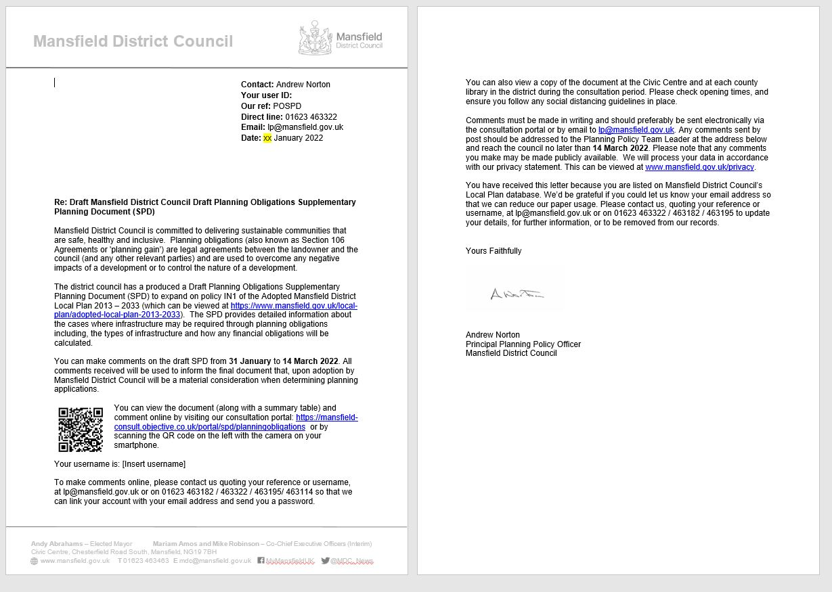

Example of email sent to agents and consultees (1,614)

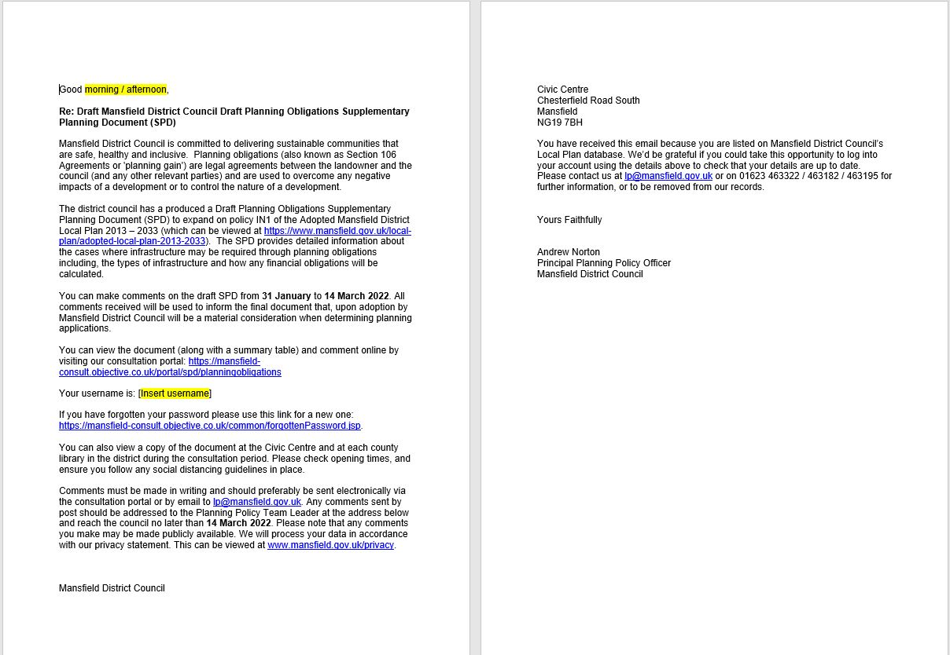

SPD Summary Document (page 1)

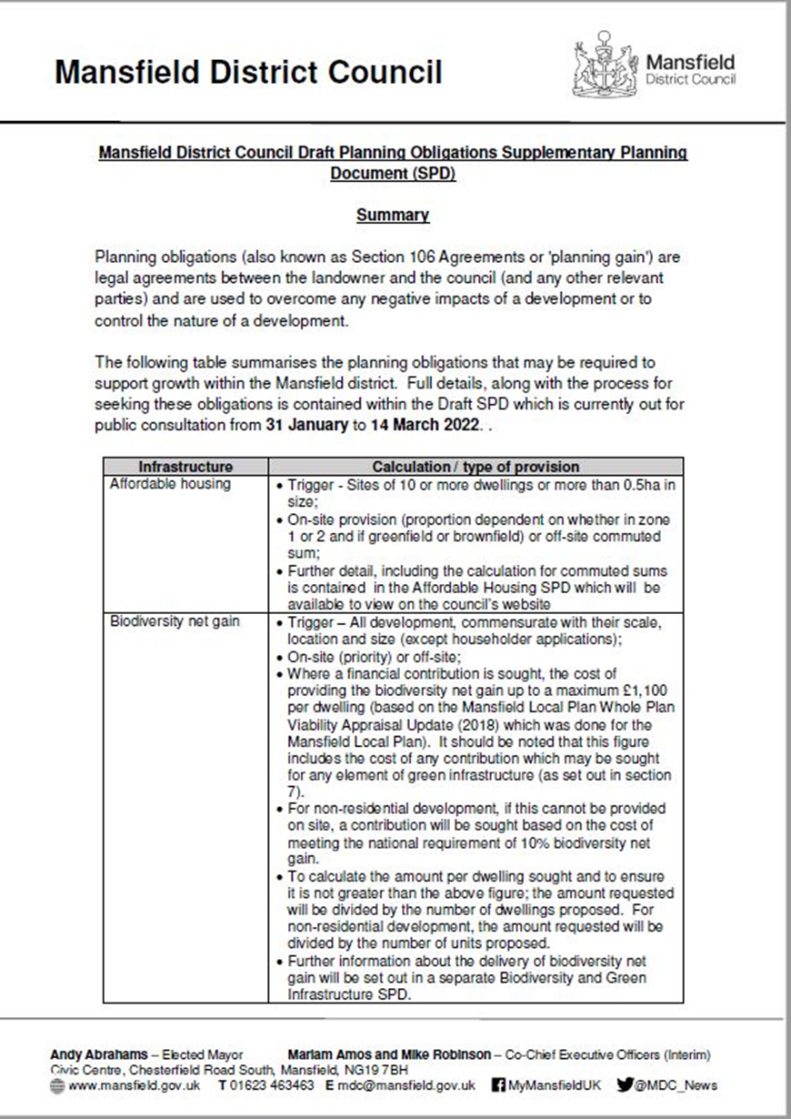

SPD Summary Document (page 2)

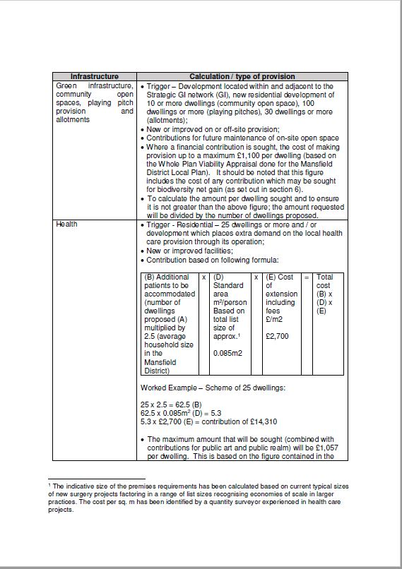

SPD Summary Document (page 3)

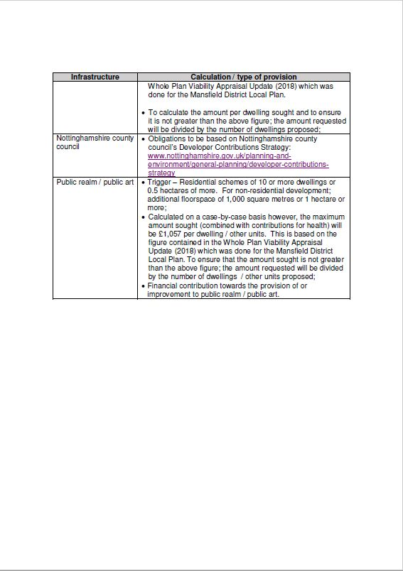

Regulation 12, 13 and 35 Consultation Statement

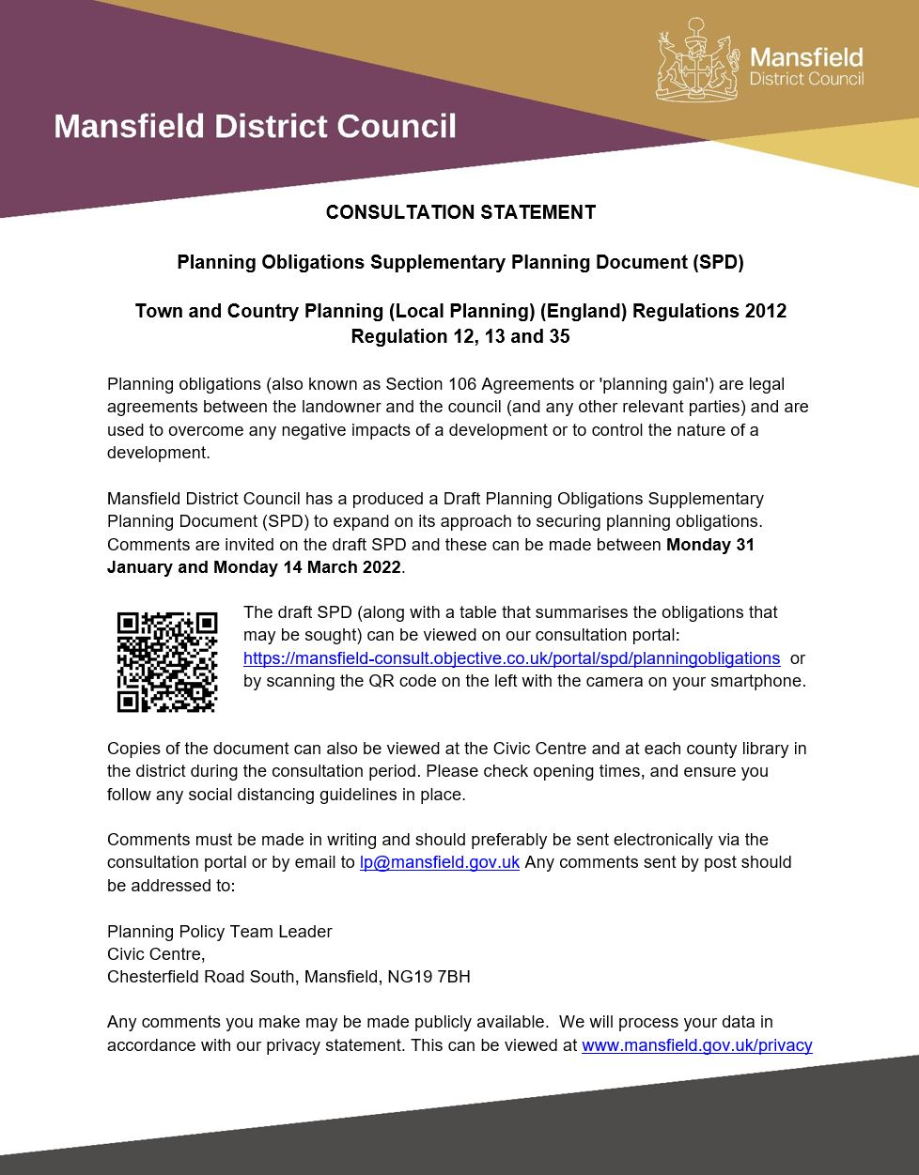

Consultation Poster - Made available at Civic Centre and libraries within the district

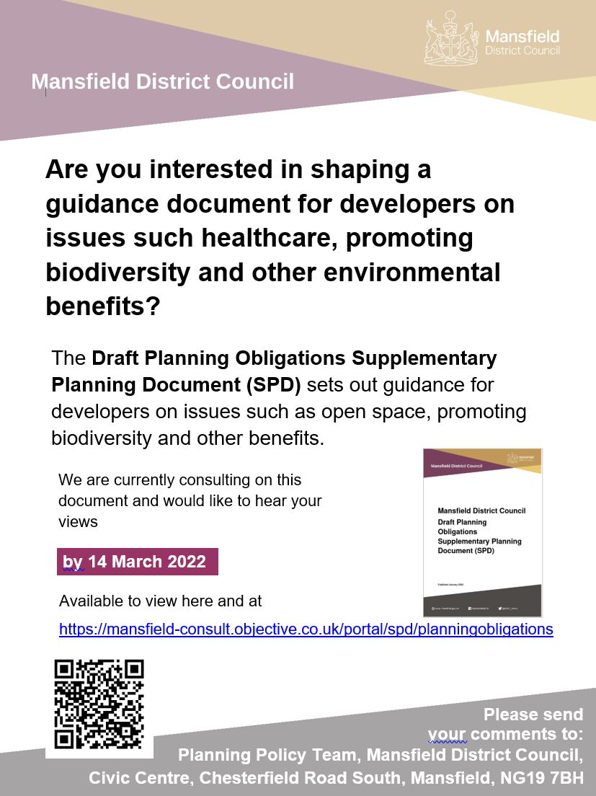

Text providing information about the consultation that appeared on Mansfield District Councils website <https://www.mansfield.gov.uk/planning-policy/consultation-planning-policies-1>

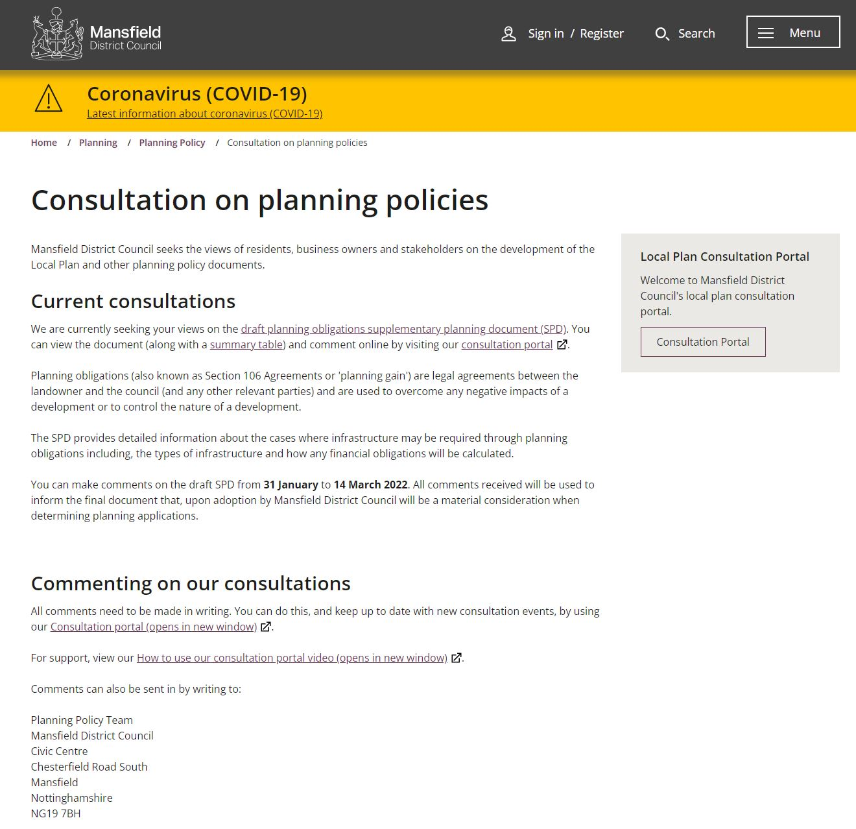

Example of press release issued on 31 January 2022 to 124 recipients

|  |  |
| --- | --- |
| cid:dff055d3-b186-47fe-abf9-f137e63e4923 | Press Release |

|  |
| --- |
| **For immediate release**  **31 January 2022**  **Public asked for views on planning process**  Are you interested in shaping a guidance document for developers on issues such healthcare and promoting biodiversity and other environmental benefits?  If so, Mansfield District Council is running a six-week public consultation from 31 January to 14 March to give everyone a chance share their opinions.  The council's Planning Policy team is in the process of producing a Planning Obligations Supplementary Planning Document (SPD).   This, along with other planning SPDs and the Local Plan, will provide developers with guidance over what kinds of planning obligations - also known as developer contributions - may be sought by the council or by other agencies such as the County Council or local Clinical Commissioning Group.   This includes obligations on matters such as the provision of open space, sports pitches and allotments and extra GP surgeries.   It also sets out how any financial obligations will be calculated. Usually such obligations are triggered where development include 10 or more dwellings or if the site is 0.5 hectares or more.  The draft document can be viewed and downloaded online at [https://mansfield-consult.objective.co.uk/portal/spd/planningobligations](https://hes32-ctp.trendmicro.com:443/wis/clicktime/v1/query?url=https%3a%2f%2ftrack.vuelio.uk.com%2fz.z%3fl%3daHR0cHM6Ly9tYW5zZmllbGQtY29uc3VsdC5vYmplY3RpdmUuY28udWsvcG9ydGFsL3NwZC9wbGFubmluZ29ibGlnYXRpb25z%26r%3d13752388335%26d%3d16203291%26p%3d1%26t%3dh%26h%3d6f5412749fd6768d22886ef6a0fd74ea&umid=5eb831a5-ed84-452c-9df8-802cb4e134d0&auth=4be54ad6eb25a559550d8aaef741acb68187dbb5-23ebd48cdf0deed85d309a49dc236e5008e60d85) and people can take part in the consultation by completing either the online or paper questionnaires.  Paper copies of the SPD can also be viewed at the Civic Centre or at libraries within the district.  Cllr Stuart Richardson, Portfolio Holder for Regeneration and Growth, said: "The council is committed to delivering sustainable communities that are safe, healthy and inclusive.  "To help achieve this, we expect new developments to provide or contribute directly towards the provision of necessary infrastructure and affordable housing to mitigate the impact of such developments.  "We want to be fair to everyone and by promoting a consistent and transparent approach to likely obligations, developers and landowners will be able to assess the potential costs and viability of a proposed development at the earliest stage. This should help make the planning process quicker and more efficient.  "Meanwhile local residents can understand how a proposed development will be accommodated with minimal environmental, social and infrastructure impact.   "Planning rules nationally are often adapted so this guidance will be subject to constant review to ensure it remains relevant and fit for purpose."  Developers, architects and anyone who submits planning applications are also invited to give their views on the council’s new Local Validation List for planning applications. The document sets out what information should be submitted with planning applications.  The updated list takes into account policy changes and new requirements for planning applications to be submitted in the district, in line with the new Local Plan. This includes information required for the council’s climate change planning policies, such as a requirement to submit a Renewable Energy Statement for major applications.  Find out how to have your say at [www.mansfield.gov.uk/planning/local-validation-list-consultation](https://hes32-ctp.trendmicro.com:443/wis/clicktime/v1/query?url=https%3a%2f%2ftrack.vuelio.uk.com%2fz.z%3fl%3daHR0cHM6Ly93d3cubWFuc2ZpZWxkLmdvdi51ay9wbGFubmluZy9sb2NhbC12YWxpZGF0aW9uLWxpc3QtY29uc3VsdGF0aW9u%26r%3d13752388335%26d%3d16203291%26p%3d1%26t%3dh%26h%3dd4afc18ea0b413bc505594024f11ac6c&umid=5eb831a5-ed84-452c-9df8-802cb4e134d0&auth=4be54ad6eb25a559550d8aaef741acb68187dbb5-6f07f5e1b3b806fe8e8295a3ccad426d9f974eac).  Both consultations close at 5pm on 14 March 2022.  To find out more about council planning policy, visit <https://hes32-ctp.trendmicro.com:443/wis/clicktime/v1/query?url=www.mansfield.gov.uk%2fplanning%2dpolicy&umid=5eb831a5-ed84-452c-9df8-802cb4e134d0&auth=4be54ad6eb25a559550d8aaef741acb68187dbb5-e92a23fddc5711230580df261baafc732ed70995>.  **- ENDS -** **For further information please contact the press office on 01623 463021 or** [**publicrelations@mansfield.gov.uk**](mailto:publicrelations@mansfield.gov.uk) **and a member of the PR team will respond to your request.**  Example of article on Mansfield 103.2 webpage – 1 February (a story was also published on the Mansfield Chad newspaper webpage on the same day)    Examples of Twitter and Facebook posts  Twitter - 8 February    Facebook – 8 February |

Examples of information about consultation as part of weekly internal MDC staff update.

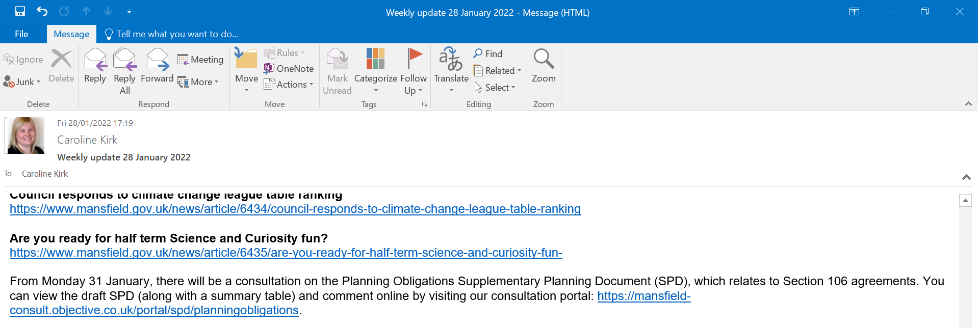

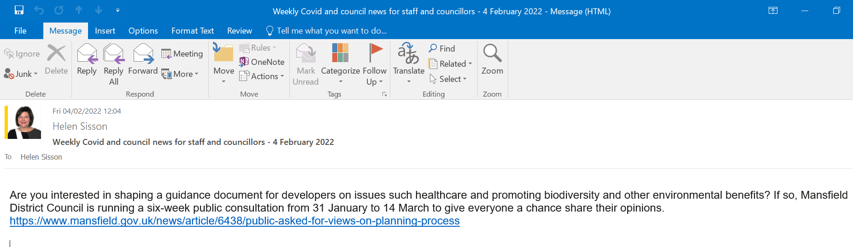

Example of email sent to those on Developers Forum mailing list (135 people and organisations) with invitation to SPD workshop

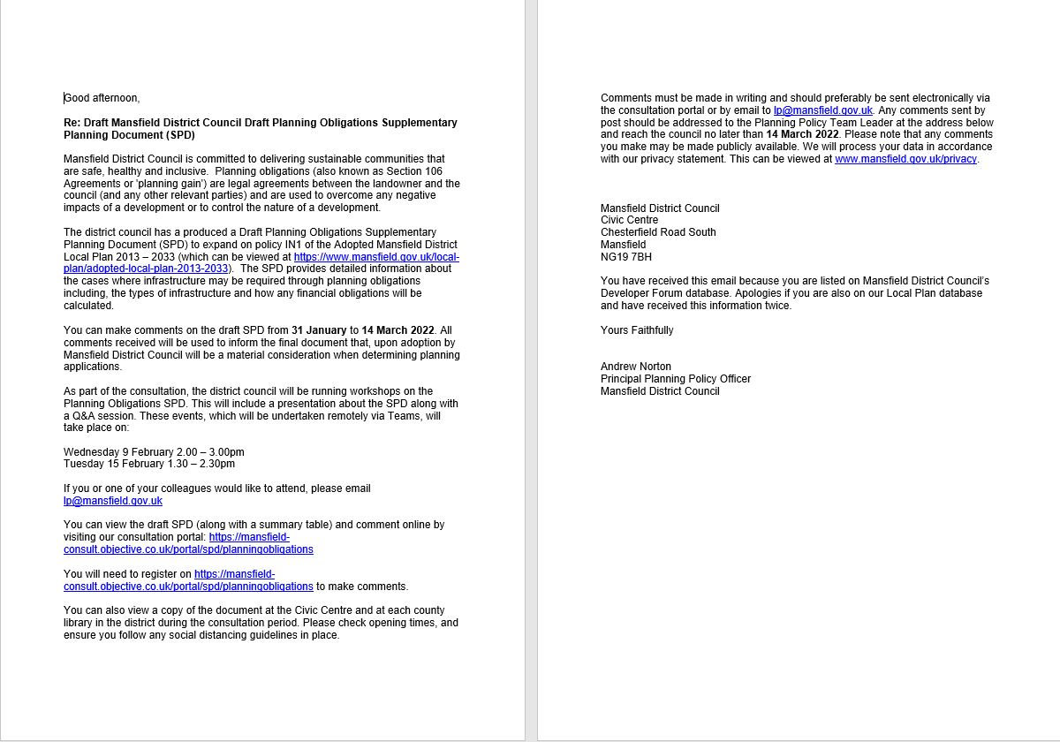

1. <https://www.mansfield.gov.uk/downloads/file/3021/adopted-sci-january-2022>
2. <https://www.legislation.gov.uk/uksi/2012/767/part/5/made>
3. <https://www.legislation.gov.uk/uksi/2012/767/part/5/made?msclkid=3beb0c7dc15e11ec95d262c038d1775e>
4. <https://www.nottinghamshire.gov.uk/planning-and-environment/general-planning/developer-contributions-strategy>